Минобрнауки России

Федеральное государственное бюджетное образовательное

учреждение высшего образования

**НИЖЕГОРОДСКИЙ ГОСУДАРСТВЕННЫЙ ТЕХНИЧЕСКИЙ УНИВЕРСИТЕТ**

**ИМ. Р.Е. АЛЕКСЕЕВА**

ИНСТИТУТ РАДИОЭЛЕКТРОНИКИ И ИНФОРМАЦИОННЫХ ТЕХНОЛОГИЙ

|  |  |  |
| --- | --- | --- |
|  |  |  |

Курс “Сети и телекоммуникации”

**Отчет по лабораторной работе №1**

Выполнил: студент группы 18 В-2

Таликов А.Ю.

Проверил: Гай В.Е.

Нижний Новгород 2020

**1. Задание на работу:**

**Задание:**

1. Собрать схему

2. Установить для каждого компьютера IP адрес, маску сети

- удалить ipv6 адреса

- запись default route – шлюз по умолчанию

3. Между компьютерам одной сети должен проходить ping, между компьютерами из разных сетей – нет.

4. Запустить wireshark. Выполнить захват пакетов, описать процесс порождения пакетов.

5. Посмотреть виртуальные интерфейсы с помощью ifconfig.

6 Вариант

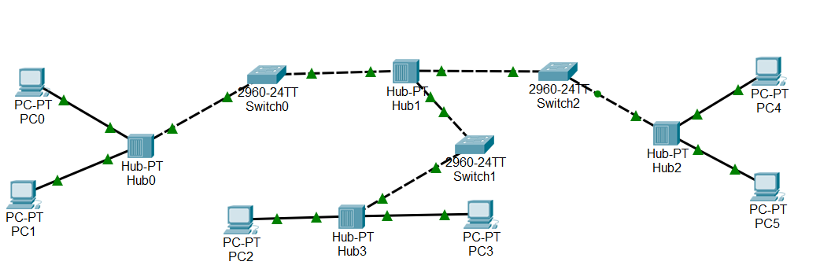

Компьютер PC2 имеет IP-адрес 10.0.1.5.

Компьютер PC1 имеет IP-адрес 10.0.2.5.

Компьютер PC4 имеет IP-адрес 10.0.64.1.

Компьютер PC3 имеет IP-адрес 192.168.1.1.

Задать IP-адреса PC0, PC5, создавая отличные от остальных ПК подсети

**2. Структура сети:**

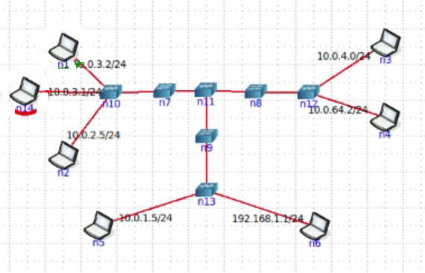

**2. Доказательства работы сети:**

Так как у меня в сети нет не одной подсети, я добавил компьютер n14 для создания подсети и сделал пингование.

Пример пингования:

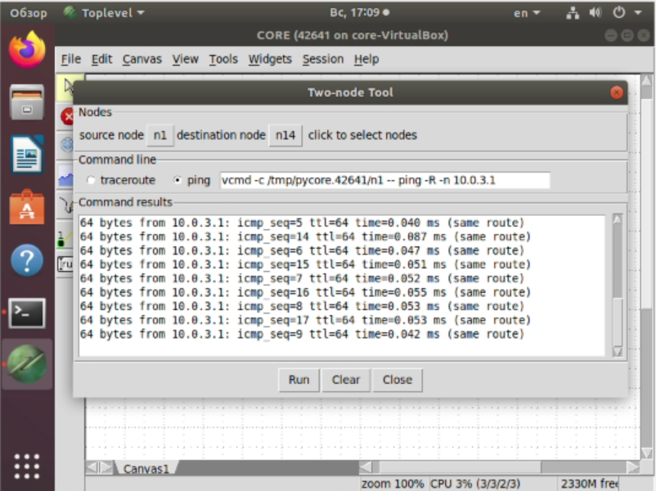

Также я запустил **WireShark** и выполнил захват пакетов и получил следующее:

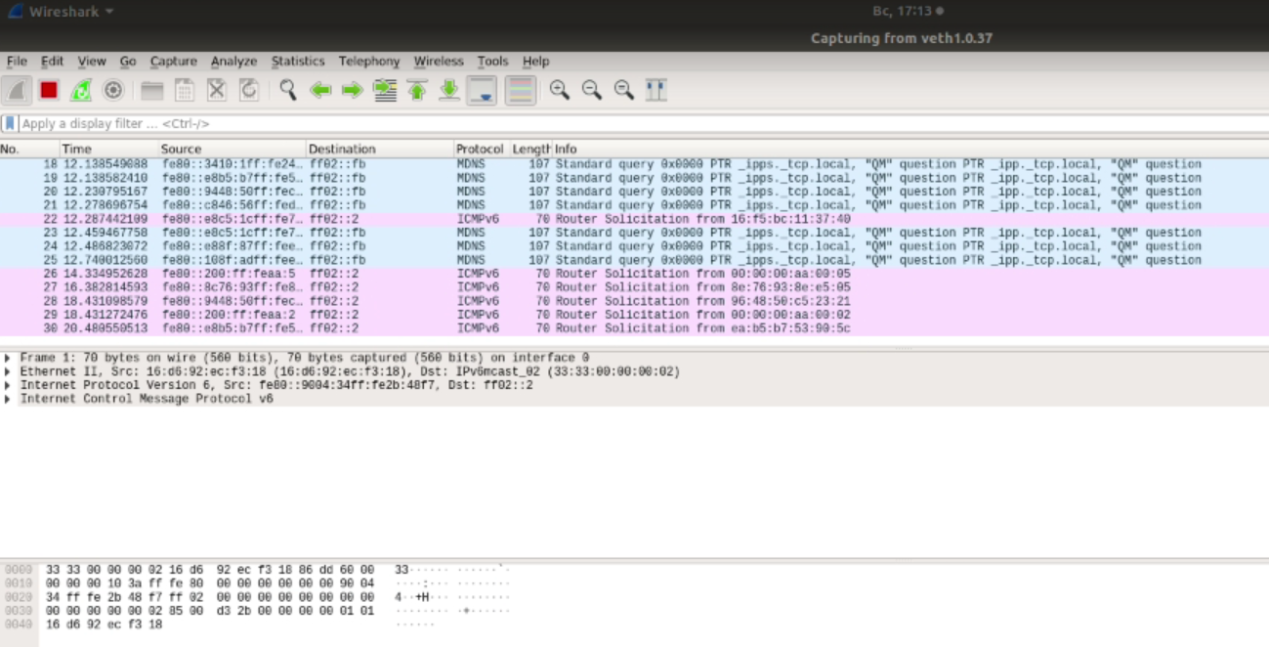

**ifconfig:**

b.10.37: flags=4163<UP,BROADCAST,RUNNING,MULTICAST> mtu 1500

inet6 fe80::a88c:80ff:fecc:34f3 prefixlen 64 scopeid 0x20<link>

ether 12:8f:ad:ee:1e:25 txqueuelen 1000 (Ethernet)

RX packets 371 bytes 36335 (36.3 KB)

RX errors 0 dropped 0 overruns 0 frame 0

TX packets 22 bytes 2643 (2.6 KB)

TX errors 0 dropped 0 overruns 0 carrier 0 collisions 0

b.11.37: flags=4163<UP,BROADCAST,RUNNING,MULTICAST> mtu 1500

inet6 fe80::e8c5:1cff:fe7a:1625 prefixlen 64 scopeid 0x20<link>

ether 16:f5:bc:11:37:40 txqueuelen 1000 (Ethernet)

RX packets 364 bytes 35701 (35.7 KB)

RX errors 0 dropped 0 overruns 0 frame 0

TX packets 28 bytes 3285 (3.2 KB)

TX errors 0 dropped 0 overruns 0 carrier 0 collisions 0

b.12.37: flags=4163<UP,BROADCAST,RUNNING,MULTICAST> mtu 1500

inet6 fe80::e84a:feff:fe19:df6d prefixlen 64 scopeid 0x20<link>

ether 0e:78:e4:0a:f8:05 txqueuelen 1000 (Ethernet)

RX packets 368 bytes 36128 (36.1 KB)

RX errors 0 dropped 0 overruns 0 frame 0

TX packets 21 bytes 2536 (2.5 KB)

TX errors 0 dropped 0 overruns 0 carrier 0 collisions 0

b.13.37: flags=4163<UP,BROADCAST,RUNNING,MULTICAST> mtu 1500

inet6 fe80::cc72:70ff:fe04:eb73 prefixlen 64 scopeid 0x20<link>

ether 36:10:01:24:1d:b3 txqueuelen 1000 (Ethernet)

RX packets 354 bytes 34879 (34.8 KB)

RX errors 0 dropped 0 overruns 0 frame 0

TX packets 29 bytes 3445 (3.4 KB)

TX errors 0 dropped 0 overruns 0 carrier 0 collisions 0

b.7.37: flags=4163<UP,BROADCAST,RUNNING,MULTICAST> mtu 1500

inet6 fe80::2840:c6ff:fe9d:2f99 prefixlen 64 scopeid 0x20<link>

ether 46:07:c6:eb:8e:8e txqueuelen 1000 (Ethernet)

RX packets 372 bytes 36395 (36.3 KB)

RX errors 0 dropped 0 overruns 0 frame 0

TX packets 22 bytes 2659 (2.6 KB)

TX errors 0 dropped 0 overruns 0 carrier 0 collisions 0

b.8.37: flags=4163<UP,BROADCAST,RUNNING,MULTICAST> mtu 1500

inet6 fe80::9004:34ff:fe2b:48f7 prefixlen 64 scopeid 0x20<link>

ether 16:d6:92:ec:f3:18 txqueuelen 1000 (Ethernet)

RX packets 372 bytes 36408 (36.4 KB)

RX errors 0 dropped 0 overruns 0 frame 0

TX packets 20 bytes 2466 (2.4 KB)

TX errors 0 dropped 0 overruns 0 carrier 0 collisions 0

b.9.37: flags=4163<UP,BROADCAST,RUNNING,MULTICAST> mtu 1500

inet6 fe80::9c11:3aff:fe27:dfda prefixlen 64 scopeid 0x20<link>

ether 1e:ac:2a:04:9f:c7 txqueuelen 1000 (Ethernet)

RX packets 362 bytes 35606 (35.6 KB)

RX errors 0 dropped 0 overruns 0 frame 0

TX packets 22 bytes 2696 (2.6 KB)

TX errors 0 dropped 0 overruns 0 carrier 0 collisions 0

enp0s3: flags=4163<UP,BROADCAST,RUNNING,MULTICAST> mtu 1500

inet 10.0.2.15 netmask 255.255.255.0 broadcast 10.0.2.255

inet6 fe80::5b19:f46c:cc5:2a82 prefixlen 64 scopeid 0x20<link>

ether 08:00:27:70:90:82 txqueuelen 1000 (Ethernet)

RX packets 760 bytes 792252 (792.2 KB)

RX errors 0 dropped 0 overruns 0 frame 0

TX packets 320 bytes 49313 (49.3 KB)

TX errors 0 dropped 0 overruns 0 carrier 0 collisions 0

lo: flags=73<UP,LOOPBACK,RUNNING> mtu 65536

inet 127.0.0.1 netmask 255.0.0.0

inet6 ::1 prefixlen 128 scopeid 0x10<host>

loop txqueuelen 1000 (Локальная петля (Loopback))

RX packets 1184 bytes 95688 (95.6 KB)

RX errors 0 dropped 0 overruns 0 frame 0

TX packets 1184 bytes 95688 (95.6 KB)

TX errors 0 dropped 0 overruns 0 carrier 0 collisions 0

veth1.0.37: flags=4163<UP,BROADCAST,RUNNING,MULTICAST> mtu 1500

inet6 fe80::108f:adff:feee:1e25 prefixlen 64 scopeid 0x20<link>

ether 12:8f:ad:ee:1e:25 txqueuelen 1000 (Ethernet)

RX packets 11 bytes 866 (866.0 B)

RX errors 0 dropped 0 overruns 0 frame 0

TX packets 380 bytes 43944 (43.9 KB)

TX errors 0 dropped 0 overruns 0 carrier 0 collisions 0

veth2.0.37: flags=4163<UP,BROADCAST,RUNNING,MULTICAST> mtu 1500

inet6 fe80::2c29:28ff:fee4:14fb prefixlen 64 scopeid 0x20<link>

ether 2e:29:28:e4:14:fb txqueuelen 1000 (Ethernet)

RX packets 11 bytes 866 (866.0 B)

RX errors 0 dropped 0 overruns 0 frame 0

TX packets 385 bytes 44390 (44.3 KB)

TX errors 0 dropped 0 overruns 0 carrier 0 collisions 0

veth3.0.37: flags=4163<UP,BROADCAST,RUNNING,MULTICAST> mtu 1500

inet6 fe80::c78:e4ff:fe0a:f805 prefixlen 64 scopeid 0x20<link>

ether 0e:78:e4:0a:f8:05 txqueuelen 1000 (Ethernet)

RX packets 11 bytes 866 (866.0 B)

RX errors 0 dropped 0 overruns 0 frame 0

TX packets 401 bytes 45806 (45.8 KB)

TX errors 0 dropped 0 overruns 0 carrier 0 collisions 0

veth4.0.37: flags=4163<UP,BROADCAST,RUNNING,MULTICAST> mtu 1500

inet6 fe80::54d1:d3ff:feb8:bd42 prefixlen 64 scopeid 0x20<link>

ether 56:d1:d3:b8:bd:42 txqueuelen 1000 (Ethernet)

RX packets 11 bytes 866 (866.0 B)

RX errors 0 dropped 0 overruns 0 frame 0

TX packets 397 bytes 45454 (45.4 KB)

TX errors 0 dropped 0 overruns 0 carrier 0 collisions 0

veth5.0.37: flags=4163<UP,BROADCAST,RUNNING,MULTICAST> mtu 1500

inet6 fe80::747b:5ff:fe33:5cf3 prefixlen 64 scopeid 0x20<link>

ether 76:7b:05:33:5c:f3 txqueuelen 1000 (Ethernet)

RX packets 11 bytes 866 (866.0 B)

RX errors 0 dropped 0 overruns 0 frame 0

TX packets 394 bytes 45184 (45.1 KB)

TX errors 0 dropped 0 overruns 0 carrier 0 collisions 0

veth6.0.37: flags=4163<UP,BROADCAST,RUNNING,MULTICAST> mtu 1500

inet6 fe80::e44c:e1ff:fe8b:cd0b prefixlen 64 scopeid 0x20<link>

ether e6:4c:e1:8b:cd:0b txqueuelen 1000 (Ethernet)

RX packets 11 bytes 866 (866.0 B)

RX errors 0 dropped 0 overruns 0 frame 0

TX packets 390 bytes 44828 (44.8 KB)

TX errors 0 dropped 0 overruns 0 carrier 0 collisions 0

veth7.b.37: flags=4163<UP,BROADCAST,RUNNING,MULTICAST> mtu 1500

inet6 fe80::4407:c6ff:feeb:8e8e prefixlen 64 scopeid 0x20<link>

ether 46:07:c6:eb:8e:8e txqueuelen 1000 (Ethernet)

RX packets 291 bytes 33240 (33.2 KB)

RX errors 0 dropped 0 overruns 0 frame 0

TX packets 127 bytes 13964 (13.9 KB)

TX errors 0 dropped 0 overruns 0 carrier 0 collisions 0

veth8.c.37: flags=4163<UP,BROADCAST,RUNNING,MULTICAST> mtu 1500

inet6 fe80::14d6:92ff:feec:f318 prefixlen 64 scopeid 0x20<link>

ether 16:d6:92:ec:f3:18 txqueuelen 1000 (Ethernet)

RX packets 69 bytes 7390 (7.3 KB)

RX errors 0 dropped 0 overruns 0 frame 0

TX packets 346 bytes 39548 (39.5 KB)

TX errors 0 dropped 0 overruns 0 carrier 0 collisions 0

veth9.d.37: flags=4163<UP,BROADCAST,RUNNING,MULTICAST> mtu 1500

inet6 fe80::1cac:2aff:fe04:9fc7 prefixlen 64 scopeid 0x20<link>

ether 1e:ac:2a:04:9f:c7 txqueuelen 1000 (Ethernet)

RX packets 76 bytes 8213 (8.2 KB)

RX errors 0 dropped 0 overruns 0 frame 0

TX packets 332 bytes 38103 (38.1 KB)

TX errors 0 dropped 0 overruns 0 carrier 0 collisions 0

vethb.7.37: flags=4163<UP,BROADCAST,RUNNING,MULTICAST> mtu 1500

inet6 fe80::c846:56ff:fede:a887 prefixlen 64 scopeid 0x20<link>

ether ca:46:56:de:a8:87 txqueuelen 1000 (Ethernet)

RX packets 127 bytes 13964 (13.9 KB)

RX errors 0 dropped 0 overruns 0 frame 0

TX packets 291 bytes 33240 (33.2 KB)

TX errors 0 dropped 0 overruns 0 carrier 0 collisions 0

vethc.8.37: flags=4163<UP,BROADCAST,RUNNING,MULTICAST> mtu 1500

inet6 fe80::e88f:87ff:feed:5585 prefixlen 64 scopeid 0x20<link>

ether ea:8f:87:ed:55:85 txqueuelen 1000 (Ethernet)

RX packets 346 bytes 39548 (39.5 KB)

RX errors 0 dropped 0 overruns 0 frame 0

TX packets 69 bytes 7390 (7.3 KB)

TX errors 0 dropped 0 overruns 0 carrier 0 collisions 0

vethd.9.37: flags=4163<UP,BROADCAST,RUNNING,MULTICAST> mtu 1500

inet6 fe80::3410:1ff:fe24:1db3 prefixlen 64 scopeid 0x20<link>

ether 36:10:01:24:1d:b3 txqueuelen 1000 (Ethernet)

RX packets 332 bytes 38103 (38.1 KB)

RX errors 0 dropped 0 overruns 0 frame 0

TX packets 76 bytes 8213 (8.2 KB)

TX errors 0 dropped 0 overruns 0 carrier 0 collisions 0